Notes on App.

- NEED AND ATTENTION TEST TO BE ADDED TO THE DIG:
Attention Baseline Battery — 3–5 minutes
1. Digit Span = Capacity
Can the mind hold a thread?
- Show number sequence.
- User repeats it.
- Increase length until failure.
- Score: longest correct span.
2. Stroop = Control
Can the mind resist the wrong impulse?
- Show color words in mismatched colors.
- User taps the ink color, not the word.
- Score: time + errors.
3. Short CPT = Endurance
Can the mind stay alert without drifting?
- Flash letters/symbols.
- User taps only target item.
- Score: misses + false taps + reaction time.
This gives you a clean first version:
Attention Score v1 =
- 33% Capacity
- 33% Control
- 34% Endurance
Simple. Defensible. Easy to explain.
**Later we should be able to incorporate phone usage, and incorporate that into a daily score based on Phone usage data, and perhaps even biometrics coming from a smart watch.

That is the bridge.
Phase 1: manual cognitive baseline
Phase 2: add phone behavior
Phase 3: add sleep / HRV / steps / workouts
Phase 4: Daniel connects it to experiments.

- NEED A BATTERY OF SIMPLE TESTS THAT USER CAN LOOK TO AT START TO KEEP SIMPLE>

Your First Battery (10 Core Tests)
These are designed to hit:
- Attention
- Discipline
- Energy
- Social baseline
No fluff.

1. No Social Media After 8PM (7 days)
Type: Removal
Goal: Improve sleep + attention
Track:
- Sleep quality (1–10)
- Morning clarity (1–10)
- Screen time at night

2. Wake Up Same Time Daily (7 days)
Type: Constraint
Goal: Stabilize rhythm + discipline
Track:
- Wake time consistency
- Energy (1–10)
- Mood (1–10)

3. Phone Outside Bedroom (7 days)
Type: Removal
Goal: Reduce impulse use + improve sleep
Track:
- Night phone usage (yes/no)
- Sleep quality
- Urge level (1–10)

4. 90-Minute Deep Work Block (5 days)
Type: Constraint
Goal: Build focus capacity
Track:
- Completed block (yes/no)
- Interruptions (#)
- Focus rating (1–10)

5. 10,000 Steps Daily (7 days)
Type: Addition
Goal: Increase baseline energy
Track:
- Steps
- Energy
- Mood

6. Protein-First Diet (7 days)
Type: Substitution
Goal: Stabilize energy + reduce crashes
Rule:
Eat protein first in every meal
Track:
- Compliance (yes/no)
- Energy
- Hunger swings

7. 10-Minute Meditation (7 days)
Type: Addition
Goal: Improve internal regulation
Track:
- Completed (yes/no)
- Calmness (1–10)
- Focus (1–10)

8. No Complaining (5 days)
Type: Constraint
Goal: Shift mental patterns
Track:
- Violations (#)
- Awareness level (1–10)
- Mood

9. 1 Real Interaction Daily (7 days)
Type: Exposure
Goal: Improve social baseline
Rule:
At least one real (non-transactional) interaction
Track:
- Completed (yes/no)
- Comfort level (1–10)
- Energy after

10. Daily Physical Training (5 days)
Type: Addition
Goal: Discipline + physical activation
Rule:
Minimum 20 minutes movement
Track:
- Completed (yes/no)
- Intensity (1–10)
- Energy after

- SOCIAL INTERACTION TESTS

Add a Social Activity Layer (but structured)
Think of social not as one test—but a progression:
- Level 1 → basic exposure
- Level 2 → engagement
- Level 3 → initiative

🔹 Here are strong Social Tests (clean + usable)

1. 3 Micro Interactions Daily (5 days)
Type: Exposure (low friction)
Goal: Break avoidance
Rule:
- Say something to 3 people (cashier, barista, gym, etc.)
Track:
- Completed (yes/no)
- Anxiety before (1–10)
- Energy after (1–10)
👉 This is your entry point test

2. Extend One Conversation (5 days)
Type: Engagement
Goal: Build conversational depth
Rule:
- Take one interaction beyond surface level
Example:
- Ask a follow-up question
- Add a personal comment
Track:
- Completed
- Comfort (1–10)
- Quality (1–10)

3. Initiate One Plan (5 days)
Type: Initiative
Goal: Move from passive → active
Rule:
- Invite someone to something
(coffee, walk, gym, etc.)
Track:
- Attempted (yes/no)
- Outcome (accepted/rejected)
- Emotional response
👉 This is a high-leverage identity test

4. Go Out Alone Once (7 days)
Type: Exposure
Goal: Independence + presence
Rule:
- Go to a social environment alone
(bar, café, event)
Track:
- Time spent
- Interactions (#)
- Comfort level

5. No Phone in Social Settings (5 days)
Type: Constraint
Goal: Increase presence
Rule:
- No phone while around people
Track:
- Compliance
- Awareness
- Interaction quality

6. 10 Messages Outbound (5 days)
Type: Volume
Goal: Increase social pipeline
Rule:
- Send 10 messages (friends, dating, etc.)
Track:
- Sent (#)
- Replies (#)
- Conversations started

7. Give 1 Genuine Compliment Daily (5 days)
Type: Positive engagement
Goal: Shift mindset + connection
Track:
- Completed
- Reaction
- Internal feeling

🔹 How this fits your system
These tests hit:
- Avoidance
- Confidence
- Initiative
- Presence
And most importantly:
They are observable and uncomfortable enough to create change

🔴 Important Design Rule
Don’t assign multiple heavy social tests at once.
Example:
❌ Bad:
- Go out alone
- Initiate plans
- 3 interactions
👉 Overload → avoidance

✅ Good:
Daniel assigns:
- “3 micro interactions”
- OR “Initiate one plan”
Not both at high intensity.

🔹 Where this gets powerful
Over time, you’ll see patterns like:
- User avoids initiation → fear of rejection
- User does volume but no depth → surface behavior
- User stays passive → low agency
Then Daniel can say:
“You’re avoiding initiative. Run this.”
Now it becomes:
Behavioral diagnosis → targeted exposure

*******INTIALLY, DANIEL SHOULD PRESCRIBE TESTS BASED ON WHAT “THE DIG SAYS.” Basically take from the battery of tests and assign. Probably no more than 3 at a time. Maybe simpler tests at first, and then getting to more complicated tests. Almost like a ladder. And the belief map should change accordingly.
ADDITIONALLY, DANIEL should ask if there is any other belief that troubles the user and that should be tested. The Test should be simple, and allow for simple input thought.

DESIGN:
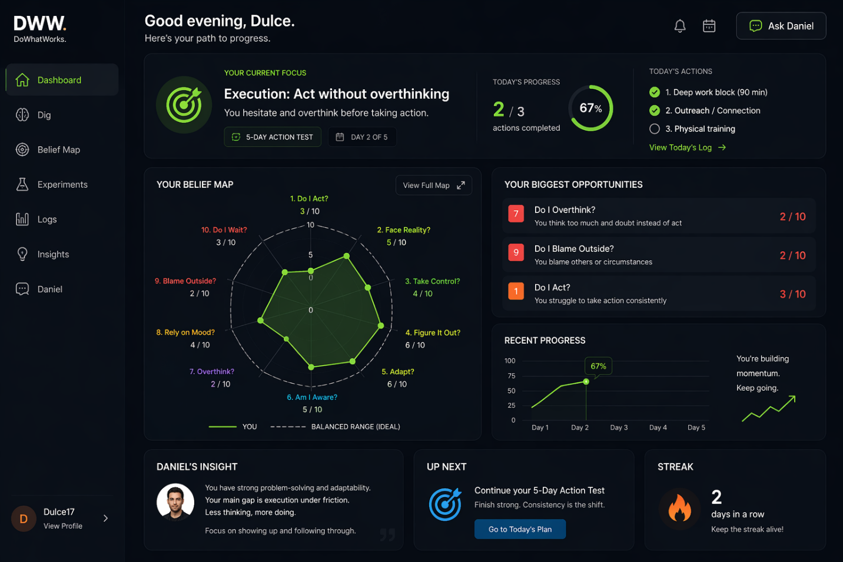

Also, notice the categories. This makes it simpler to understand for the user.
See Below.
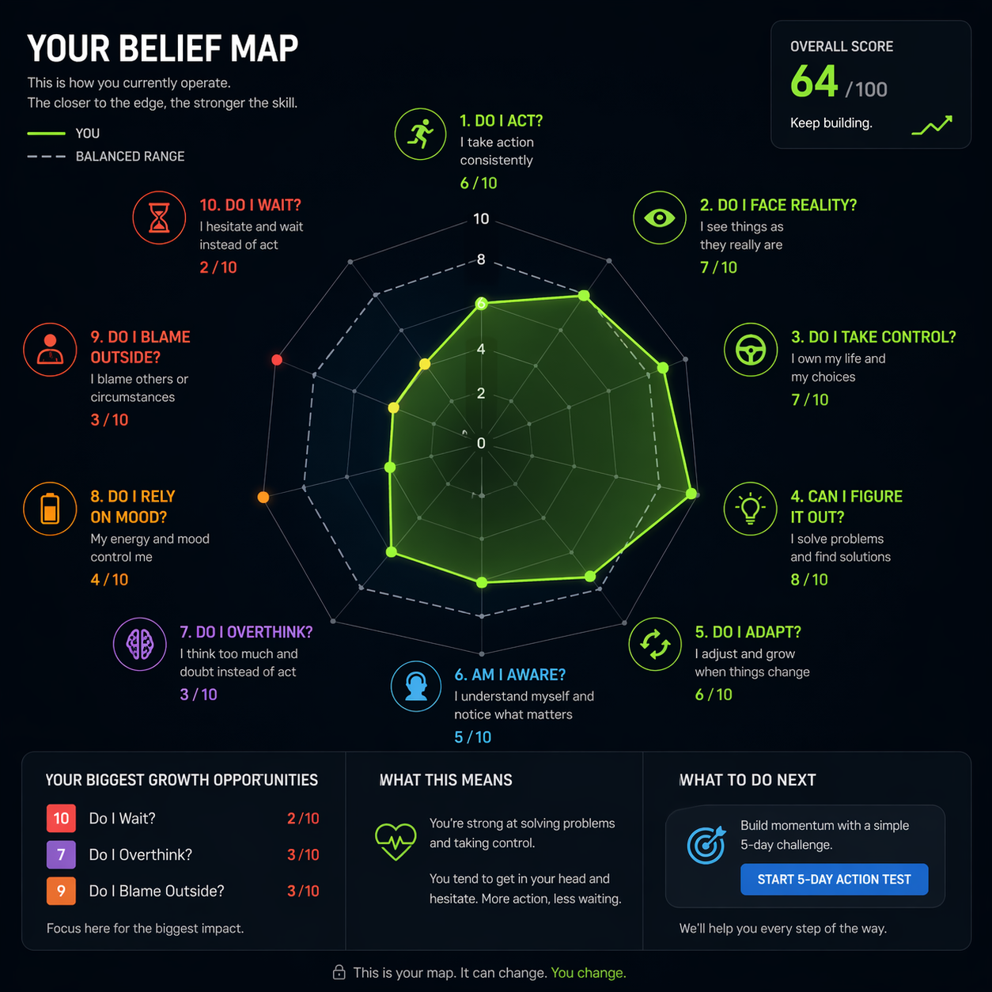

Basically making the categories or dimensions simpler.

For example, below is my Belief Map.
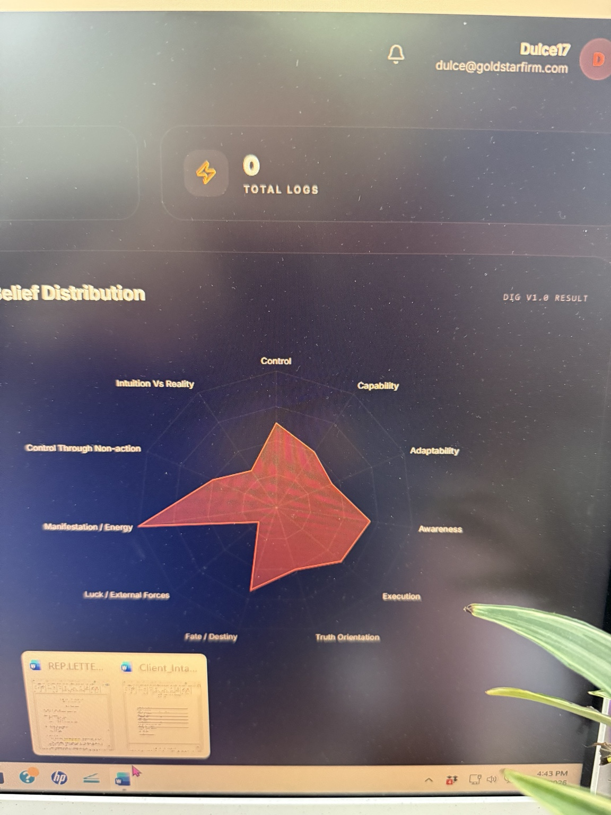

So categories should be like this:

CATEGORY SIMPLIFICATION
Keep your structure, sharpen wording:
- Control → Do I Take Control?
- Capability → Can I Figure It Out?
- Adaptability → Do I Adjust?
- Awareness → Am I Aware?
- Execution → Do I Act?
- Truth → Do I Face Reality?
- Fate → Do I Wait?
- Blame → Do I Blame Outside?
- Energy → Do I Rely on Vibes?
- Avoidance → Do I Avoid Action?
- Intuition → Do I Trust Feelings Over Facts?

THINK we May need to tighten to:
Here’s the tightened version:
- Do I Take Control?
- Can I Figure It Out?
- Do I Adjust?
- Do I Catch Myself?
- Do I Act?
- Do I Face Reality?
- Do I Avoid Action? ✅ (replaces “Do I Wait?”)
- Do I Blame Outside?
- Do I Rely on Vibes?
- Do I Trust Feelings Over Facts?
*Want to get your thoughts on that.
Wondering, whether the below Dashboard makes more sense:

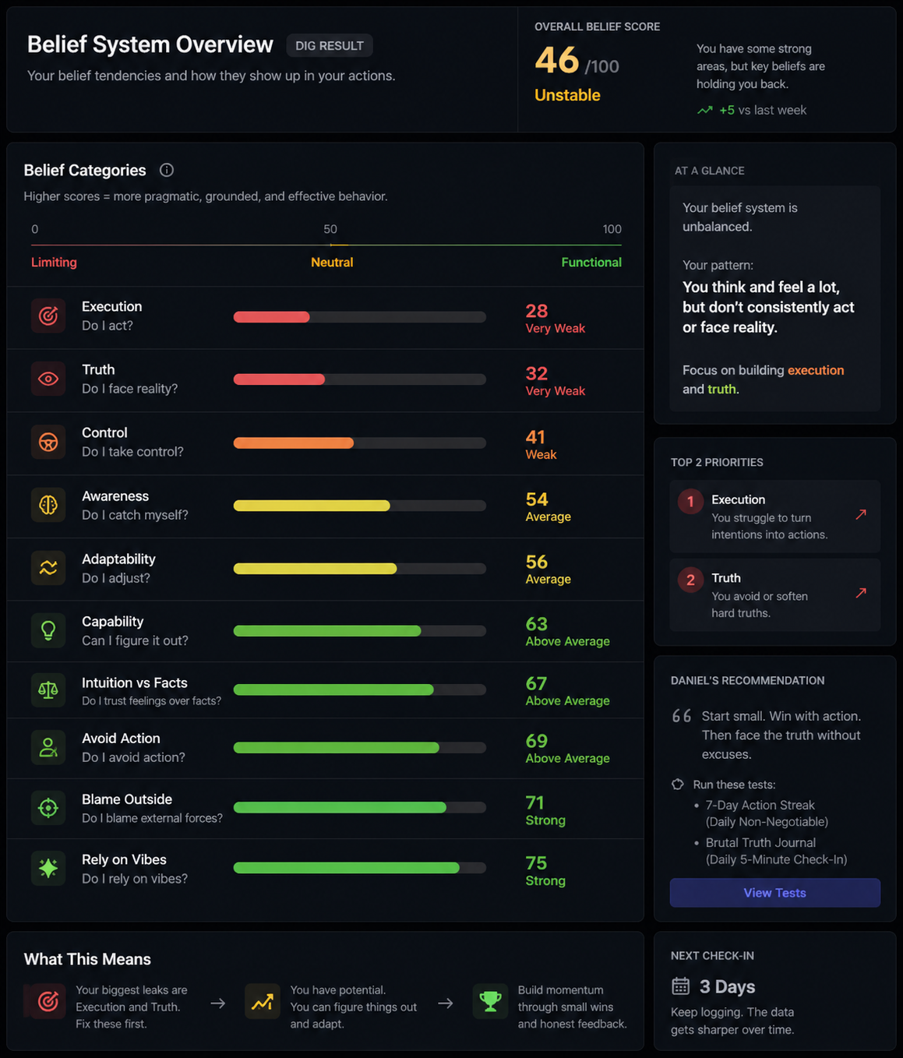
This may be a better model. For the home screen.

